**State wise Computer and Internet users in India 2011**

Source: <http://updateox.com/india/state-wise-internet-users-in-india-census-2011/>

| **State** | **Households** | **Computers** | **%** | **With Internet** | **%** | **Without Internet** | **%** |
| --- | --- | --- | --- | --- | --- | --- | --- |
| **INDIA** | **246692667** | **23189111** | **9.4** | **7647473** | **3.1** | **15541638** | **6.3** |
| Jammu & Kashmir | 2015088 | 169267 | 8.4 | 58438 | 2.9 | 110830 | 5.5 |
| Himachal Pradesh | 1476581 | 124033 | 8.4 | 41344 | 2.8 | 82689 | 5.6 |
| Punjab | 5409699 | 692441 | 12.8 | 292124 | 5.4 | 400318 | 7.4 |
| Chandigarh # | 235061 | 78040 | 33.2 | 44191 | 18.8 | 33849 | 14.4 |
| Uttarakhand | 1997068 | 219677 | 11 | 63906 | 3.2 | 155771 | 7.8 |
| Haryana | 4717954 | 622770 | 13.2 | 250052 | 5.3 | 372718 | 7.9 |
| NCT of Delhi # | 3340538 | 972097 | 29.1 | 587935 | 17.6 | 384162 | 11.5 |
| Rajasthan | 12581303 | 868110 | 6.9 | 226463 | 1.8 | 641646 | 5.1 |
| Uttar Pradesh | 32924266 | 2666866 | 8.1 | 625561 | 1.9 | 2041304 | 6.2 |
| Bihar | 18940629 | 1344785 | 7.1 | 170466 | 0.9 | 1174319 | 6.2 |
| Sikkim | 128131 | 14735 | 11.5 | 4228 | 3.3 | 10507 | 8.2 |
| Arunachal Pradesh | 261614 | 21452 | 8.2 | 5232 | 2 | 16220 | 6.2 |
| Nagaland | 399965 | 35597 | 8.9 | 6799 | 1.7 | 28797 | 7.2 |
| Manipur | 507152 | 45644 | 9 | 10650 | 2.1 | 34993 | 6.9 |
| Mizoram | 221077 | 33604 | 15.2 | 5527 | 2.5 | 28077 | 12.7 |
| Tripura | 842781 | 60680 | 7.2 | 8428 | 1 | 53095 | 6.3 |
| Meghalaya | 538299 | 40911 | 7.6 | 8074 | 1.5 | 32836 | 6.1 |
| Assam | 6367295 | 592158 | 9.3 | 101877 | 1.6 | 490282 | 7.7 |
| West Bengal | 20067299 | 1665586 | 8.3 | 441481 | 2.2 | 1224105 | 6.1 |
| Jharkhand | 6181607 | 426531 | 6.9 | 92724 | 1.5 | 333807 | 5.4 |
| Odisha | 9661085 | 492715 | 5.1 | 135255 | 1.4 | 357460 | 3.7 |
| Chhattisgarh | 5622850 | 258651 | 4.6 | 67474 | 1.2 | 191177 | 3.4 |
| Madhya Pradesh | 14967597 | 883088 | 5.9 | 209546 | 1.4 | 673542 | 4.5 |
| Gujarat | 12181718 | 1071991 | 8.8 | 377633 | 3.1 | 694358 | 5.7 |
| Daman & Diu # | 60381 | 5615 | 9.3 | 1691 | 2.8 | 3925 | 6.5 |
| Dadra & Nagar Haveli # | 73063 | 6064 | 8.3 | 2046 | 2.8 | 4018 | 5.5 |
| Maharashtra | 23830580 | 3169467 | 13.3 | 1382174 | 5.8 | 1787294 | 7.5 |
| Andhra Pradesh | 21024534 | 1766061 | 8.4 | 546638 | 2.6 | 1219423 | 5.8 |
| Karnataka | 13179911 | 1687029 | 12.8 | 632636 | 4.8 | 1054393 | 8 |
| Goa | 322813 | 100395 | 31.1 | 40997 | 12.7 | 59398 | 18.4 |
| Lakshadweep # | 10703 | 1509 | 14.1 | 332 | 3.1 | 1177 | 11 |
| Kerala | 7716370 | 1219186 | 15.8 | 486131 | 6.3 | 733055 | 9.5 |
| Tamil Nadu | 18493003 | 1960258 | 10.6 | 776706 | 4.2 | 1183552 | 6.4 |
| Pondicherry # | 301276 | 40974 | 13.6 | 18077 | 6 | 22897 | 7.6 |
| A&N Islands # | 93376 | 8217 | 8.8 | 3268 | 3.5 | 4949 | 5.3 |

[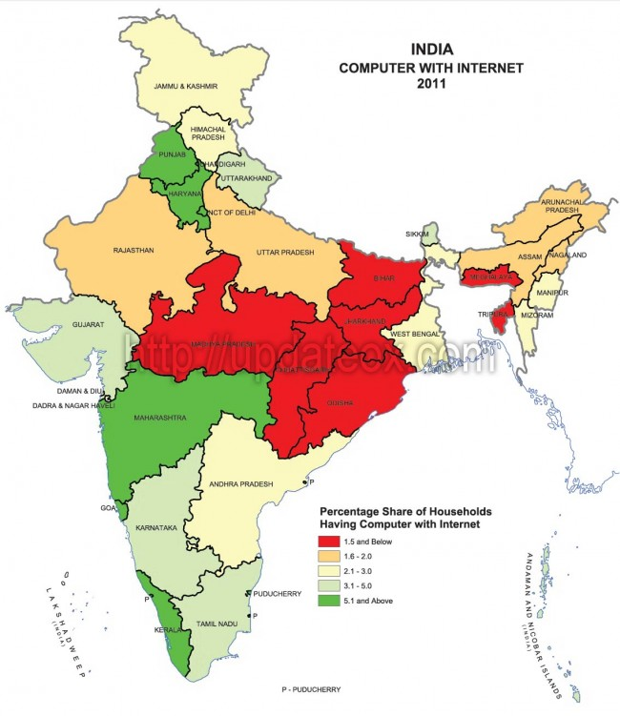](http://updateox.com/wp-content/uploads/2012/04/Map-of-State-wise-Percentage-of-Computers-with-Internet-access-in-India.jpg)